DRAMA: The Vikings
Drama CofE Benchmarks covered in the unit
I can create, adapt and sustain different roles, experimenting with movement, expression and voice and using theatre arts technology. EXA 2-12a
• Chooses voice appropriately for role, considering volume, tone, clarity, pace, characterisation, and emotion.
• Chooses appropriate movement for role, for example, to convey the character’s setting, physical features, the character’s feelings.
• Chooses relevant expression in role, showing how the character might interact with others, for example, through body language.
• Uses movement, expression and voice to create atmosphere, for example, a high-pitched voice, wide eyes and crouched body to suggest a frightening situation.
Inspired by a range of stimuli, I can express and communicate my ideas, thoughts and feelings through drama. EXA 2-13a
I have created and presented scripted or improvised drama, beginning to take account of audience and atmosphere. EXA 2-14a
• Creates a short drama, as part of a group or individually, using improvisation or a published script.
• Builds on the contributions of others in developing ideas for a shared drama, with regard to plot, characters and theatre arts.
• Presents a short drama, as part of a group, using improvisation or a script.
• Uses theatre arts technology such as props, basic lighting and sound to enhance a performance effectively, for example, chooses appropriate music or makes sound effects to create atmosphere.
I can respond to the experience of drama by discussing my thoughts and feelings. I can give and accept constructive comment on my own and others’ work. EXA 2-15a
• Gives a personal response to drama experiences, with appropriate justification.
• Explains, with supporting reasons, what works well and what could be improved in their own and others’ work, using appropriate drama vocabulary.

Lesson 1
ACTIVITY 1: CREATING ATMOSPHERE
Play MUSIC, ideally dramatic Viking style music like https://www.youtube.com/watch?v=Li9Vi_-Nufk or https://www.youtube.com/watch?v=kLTbBnBS3gE . Allow kids to sit in the space and listen. Encourage imagining. Allow feedback. What did the music make them think of? Allow wide range of answers and encourage even unusual ideas.
ACTVITY 2: Explain that this game is a variant on Musical Statues. It’s called DRAMATIC STATUES. To the music, kids will move around the space. When music stops, you will give commands and then count down 3,2,1, FREEZE! The aim is to be still – and DRAMATIC, so encourage kids to exaggerate their facial expressions and poses.
Commands can include:
- You have just discovered your village has been burnt down
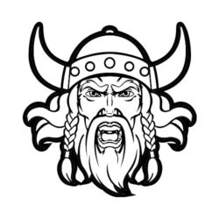
- You are in the middle of a sword fight
- You have just jumped into the freezing sea
- You are eating seal stew
- You have just dropped your shield onto your bare toes
- You are running into battle
- You have just found a huge treasure
- You are dancing on the table at a feast
- You are listening with rapt attention to a skald storyteller.
I’d resist putting people out unless everyone in the class can handle it. It might be better to praise very dramatic and inventive poses, and very still statues. Good photo opportunity!
ACTIVITY 3: VIKING CHARADES
Get kids into groups or choose volunteers to perform to the whole class. Get them to act the following out for their peers to guess:

- Helmet
- Adventure
- Ship
- Storm
- Village
- Fight
- Beard
- Axe
- Wool
- Saga/story
- Chief
- Board games
- Fish
- Hunting
- Brave
- Gods
- Treasure
- Sword

Lesson 2
ACTIVITY 1: WARM-UP
You will need a whistle or tambourine
Battle cry: Line kids up opposite each other in two opposing battle lines.
Explain that you are looking for aggressive voice and movement as both lines charge towards each other as in a Viking battle. On your whistle or signal, pupils should utter a blood-curdling battle cry and charge forward in slow motion. On your second signal and before the two lines actually meet, they should freeze in a mid-movement pose and hold it for 10 second without corpsing (coming out of character). No-one should laugh.
You may have to repeat the challenge until pupils are focused enough to stay in character.
ACTIVITY 2: TABLEAU OF A VIKING RAID
Explain that each group of 8 or so needs to create a standalone frozen picture of a Viking raid on a village. Allow 2 minutes for quiet discussion and 4 minutes for practice. Poses should be dynamic and dramatic.
Allow a rolling performance where you play the music with lights down. One group comes up and gets into position. Lights up for 10 seconds while they hold the pose. Lights down for the first group to vacate the stage and the next group gets ready. Repeat until all groups have performed.
Allow brief time of evaluation.
ACTIVITY 3: INTRODUCE HEROIC SAGAS/Hero Statues
Explain that sagas of the Viking Age usually focus on a hero who has a range of adventures or challenges. A Viking hero may, for example, leave his home village to track down an enemy or sail to the end of the earth. On this quest, he may meet magic and monsters and fight villains and spectres.
In pairs, get kids to shape each other into HERO STATUES. Discuss gestures, stance, posture. Which statue is most effective and why? If there is enough time, allow a heroes’ gallery: Half the class stay as statues and the others can walk around inspecting the statues (no touching!). Then swap over. Which statues were particularly effective and why?

Lesson 3
ACTIVITY 1 BRIEF RECAP: Remind pupils of the saga, the episodic structure, the hero, the mixture of mortal enemies and magical obstacles and challenges.
ACTIVITY 2 VIKING DRAMA CREATION: In groups of 5, allow pupils to begin their own hero saga.
- To begin they need to name a hero and why not give him two sidekicks. Make them good Viking names with interesting descriptions. Choose the actors.
- Then choose three obstacles or enemies they have to overcome in their quest journey.
- Finally, complete a scene breakdown. Only when all this is completed should the groups rehearse.
Viking Saga performance
You are going to create a Viking saga.
Characters:
- Hero/heroine’s name:
- Sidekick 1:
- Sidekick 2:
Scene Breakdown (take notes for each):
Scene 1: Leaving for the quest _____________________________________________________
____________________________________________________________________________________
____________________________________________________________________________________
Scene 2: adventure 1 ______________________________________________________________
____________________________________________________________________________________
____________________________________________________________________________________
Scene 3: adventure 2: _____________________________________________________________
___________________________________________________________________________________
Scene 4: adventure 3: _____________________________________________________________
___________________________________________________________________________________
Scene 5: Return home: _____________________________________________________________
_____________________________________________________________________________________
Props:
Lesson 4
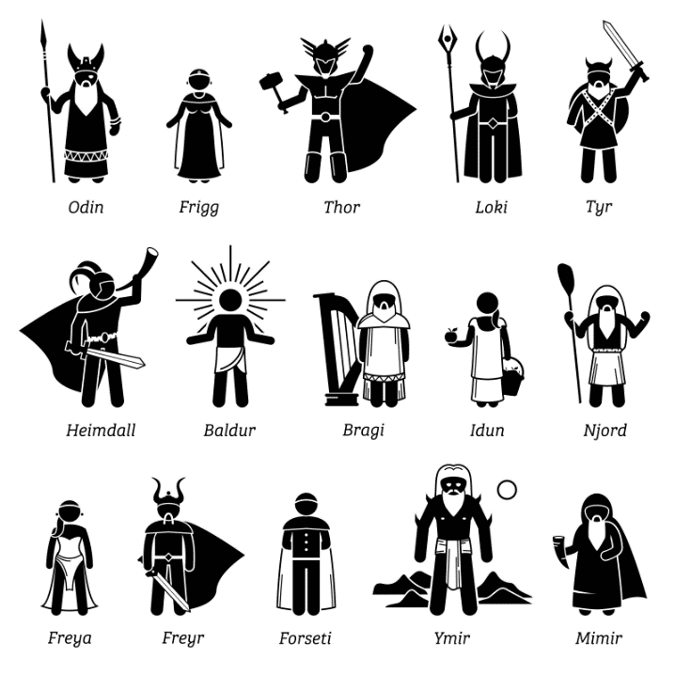
ACTIVITY 1 WARM UP: NORSE GODS FRUIT SALAD STYLE GAME
Kids sit in circle on chairs. Instead of counting them off, use names of Norse gods: ‘Thor’, ‘Loki’, ‘Freya’, ‘Odin’. Kids need to remember which name they have been given. You shout out a name and all kids with that name need to jump up and find a different seat. You can remove seats and put kids out if needed.
When you shout ‘Valhalla,’ all kids have to get up and find a different seat.

ACTIVITY 2: REHEARSAL
Give kids the chance to rehearse their hero saga plays as planned last session. Props and costume should be minimal.
ACTIVITY 3: PERFORMANCE
Groups should perform their hero plays to the class
ACTIVITY 4: EVALUATION
Informal verbal feedback should be given after each performance. Praise postcards should be given for the most outstanding performances or the most inventive Drama ideas.
You may want to prep one capable child to be the skald storyteller at next lesson’s Role-play.
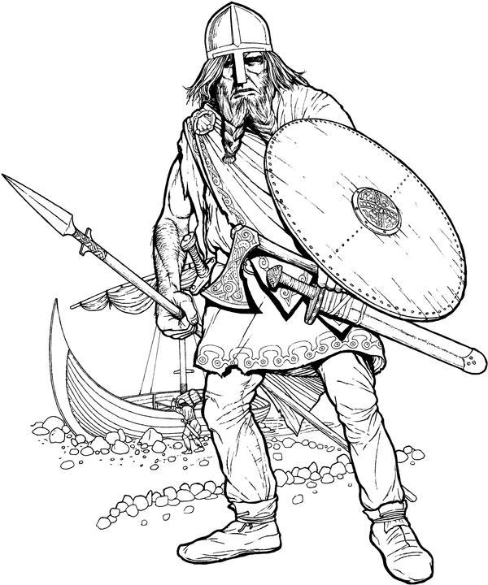

Lesson 5
AHEAD OF THE LESSON:
A child or classroom assistant should be prompted to be the skald (Viking storyteller) but must not let the others know. They should choose one Viking saga to tell at the feast. There are plenty at https://www.bbc.co.uk/programmes/articles/20stJyBvh9mv7kpSVgDfKPw/viking-sagas-age-7-11 for them to prepare.
ACTIVITY 1 Introducing Role-play
Explain to kids that you are going to create a Role-play. Agree a signal (tambourine? Bell? Whistle? Clap?) This will signify that the Role-play begins or stops. From the signal, everyone needs to be in role. Teacher in role as Chief or Jarl.
In preparation, discuss how a Viking may speak (they might get progressively more drunk, fall asleep under the table etc). They might use old Norse expressions sprinkled into their improvisations. They can also throw things like ‘By Odin’ or ‘By Thor’ or ‘For Freya’s sake!’

Já - Yes
Nei – No
Sæl - Hello!
Far vel – Goodbye
Gott kveld - Good evening!

Now discuss how a Viking might move. Broad stance, uncivilised eating, throwing bones over shoulder or to the dogs? Motioning to the thralls (Viking slaves) to serve more beer? Drinking out of horns etc. Brainstorm ideas.
Now discuss how the room should look. Create a long table, for example, or a long bench with students sitting on the floor. Discuss where the barrels of drink are and assign warrior and thrall roles.
ACTIVITY 2 ROLE-PLAY
Teacher in role. As Chief, welcome everyone, staggered, to the table and order thralls to serve. Make a speech about the recent, successful raiding trip to Ireland and the Hebrides. Praise the heroic deeds of a couple of pupils and ask them to tell the crowd how they defeated the dragon/giant, or how they sailed the ship through the whirlpool. Encourage exaggeration. Lead reactions.
Make sure everyone is served, boss the thralls about, threaten with interesting threats like ‘Get me another horn of mead or I’ll feed you to Freya’s cats’ or ‘May Thor’s Hammer strike you into the ground for spilling my drink, you useless servant’ etc…
Invite fellow Vikings to share memories of heroic deeds, then say that it is time for the Skald to tell a saga.
The skald tells the story. Threaten anyone who interrupts with terrifying Viking threats. If anyone persists, have him or her thrown out of the drinking hall.
After the story, if pupils’ improvisation hasn’t taken you in a different direction, pick a fight with someone. Slow Motion Brawl can ensue. Chase pupils out or bring the improvisation to an end by giving the agreed signal.
ACTIVITY 3: EVALUATE ROLE-PLAY
Role-play Evaluation
I enjoy creating, choosing and accepting roles, using movement, expression and voice. EXA 1-12a I can create, adapt and sustain different roles, experimenting with movement, expression and voice and using theatre arts technology. EXA 2-12a
Draw a picture and write a sentence of your most memorable moment in the Role-play and add labels or a caption:

Caption:

What HOTS skills did we use in our Role-play?

Remembering ⃝
Creating ⃝
Understanding ⃝
Applying ⃝
Analysing ⃝
Evaluating ⃝

What worked well?
1. _____________________________________________________
2. _____________________________________________________
What needed improvement?
1. ______________________________________________________
2. ______________________________________________________

Rate your own contribution out of 5 smiley faces
⃝ ⃝ ⃝ ⃝ ⃝
Why?
________________________________________________________
________________________________________________________
What role did you create?
________________________________________________________

Did you use movement? Give an example.
________________________________________________________
________________________________________________________

Did you use voice? Give an example.
________________________________________________________
________________________________________________________
Write one sentence about your enjoyment of the Viking Role-play:
________________________________________________________
________________________________________________________

LESSON 6
ACTIVITY 1: The Chessmen Thief QUIZ
Tape a line (or two if class is big) on the floor and get pupils to stand on the line. Explain that you will read a statement which is either true or false. You’ll then count to three. On the count of three, kids jump forward for ‘true’ and backwards for ‘false’. There are ten statements. Kids can keep track of their own score OR (if you want to be competitive about it) you can put pupils out who get it wrong, to see who is the last pupil standing. After this round, pupils can create their own true and false question and practise jumping with a Viking roar, like Jarl Magnus.
- The story begins in Scotland. (False, in Norway)
- Kylan has blond hair. (False, he is described as ‘the Redhead’)
- The sailors have to negotiate a whirlpool. (True, the Swelkie)
- Ingirid teaches Kylan to play Hnefatafl. (False, Chess)
- There is a snowy owl in the book. (False, barn owl)
- Kylan wants to return to Orkney. (False, Lewis)
- The Chessmen were buried on a beach on the Isle of Lewis. (True)
- Jarl Magnus goes berserk. (False)
- The Archbishop’s scholar dies. (True)
- The hero of the Stoorworm story is called Asgard. (False, Assipattle)
ACTIVITY 2: PUPIL FEEDBACK ON VIKING HERITAGE DRAMA UNIT
Make sure each pupil has a post-it note or similar to work on. Brainstorm all the elements of Viking Drama we have covered: statues, sagas, Role-play etc. Ask pupils to REFLECT on the whole topic and respond on the post-it note or piece of paper: What was their favourite part? What was most memorable? What would they rate the Viking unit out of 10? These can form a class display with photos and/or drawings.

