Teaching Resources
Fir for Luck
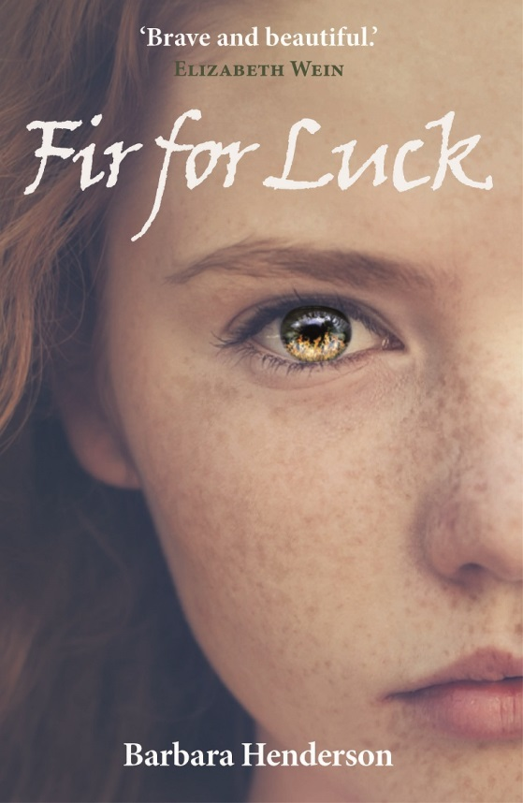
By Barbara Henderson

Before you begin…
Homework Task
1. Search for images of the Highland Clearances. Photography was only just invented, but you might find pictures of ruins, paintings/illustrations etc. Bring an image to school to create a class collage for your unit.
2. Research the Highland Clearances online or at a library. Write down three facts, a sentence for each. Be sure to use correct punctuation and spelling.

At School
1. Got your pictures?
Assemble the images into a display. This will serve as a heading for further work you create
2. What were the Highland Clearances?
Each pupil can now share one interesting fact about the Highland Clearances. Avoid repeating the same information.
All of this will serve as a background to your study of Fir for Luck.
3. How can a village just disappear?
Borrow maps or atlases from Geography or request free maps from VisitScotland. Each pupil should cut/glue or draw a rough map of Sutherland into their jotters. The map should contain Durness, Tongue, Dornoch, Altnaharra, Rispond.
Ceannabeinne, Fir for Luck’s setting, is between Durness and Rispond. As it isn’t there anymore, it is not marked on maps.
This can serve as a reference point throughout the novel study.
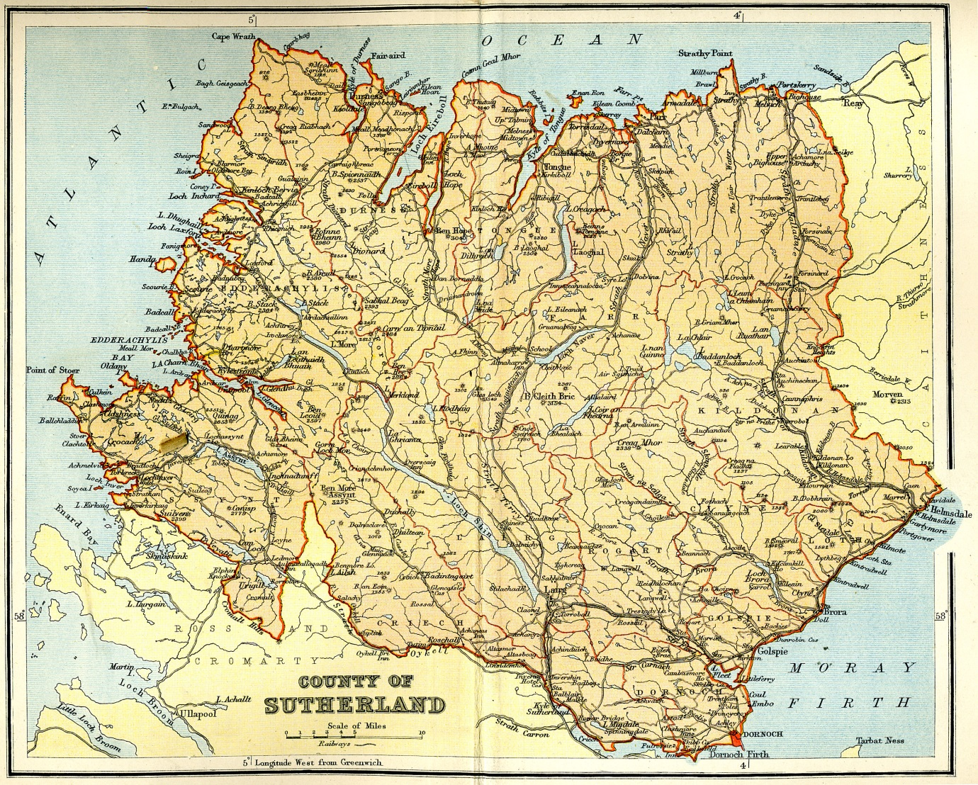
Source: http://www.electricscotland.com/history/gazetteer/images/sutherland_map.jpg

Questions for Discussion
Chapter 1 Strathnaver, 1814: The Inferno
- ‘Anna’s breaths came fast now’
What does this suggest about how she is feeling?
- ‘Anna’s brain whirled’ What does this mean here?
- ‘Furious flames licked the grey stones charcoal-black’ What type of images are being used here? What do they suggest?
- ‘Hell’ and ‘inferno’ are religious words. What do they suggest about how bad things were, and about how much influence the villagers had?
Chapter 2 Ceannabeinne: 1841
- In what three ways is the flashback in Chapter 1 from the main story? Why?
- Find two quotes as evidence that the longhouse is a comfortable home.
- ‘…one of her tunes from Strathnaver’ What could be the link between Granna and the flashback in Chapter 1?
- The ‘fir for luck’ in the hearth chain is a superstition. Can you think of any modern superstitions? And what do people believe may bring them luck today?
Chapter 3 The Ceilidh
- ‘Shame we couldn’t have afforded a thicker chain to hang the pot, like the Mackays up in the Top House.’ What does this suggest about how wealthy the families are in comparison?
- How would you describe Wee Donald in three words?
- Why is Janet so keen to go thatch-cutting? (page 7)
- Find another piece of evidence that Granna is linked to the flashback in Chapter 1.
Chapter 4 Bent Day
- What are the clues in the text to show us that Janet is angry? Find at least three quotes on pages 16-19.
- How does Janet feel about the Schoolmaster, Wee Donald and Mary Mackie? Find evidence for your choice.
- ‘Hang on’ on p.21 begins a build-up of tension. The chapter ends on a cliff-hanger. What questions do you have as reader at this point?

Chapter 5 The Writ
- Is Peggy a likeable character? Give evidence for your choice.
- ‘Only the worst kind of men have no stains on their coats, Granna says.’ (p.24) What is suspicious about men with clean coats? Why are they different from Janet’s family?
- ‘Doors open. Hens scatter. Still I scream.’ What is different about the sentence structure here, compared to what went before? Why?
- ‘What a cowardly, cowardly thing to do.’ What is Janet’s mother referring to here? What is cowardly?
- Put the writ (p.26) into your own words.
- Do you think the flashback ‘Strathnaver 1814: The Writ’ (p.35-37) takes place before or after Chapter 1?
Chapter 6 The Meeting
- What additional information do you learn about the Top House Mackays in this chapter?
- Why do the villagers turn to the church minister for help?
- Why would the sheriff officers ‘come for’ Isabella and the Seamstress?
- ‘When I turn spy’ is another cliff-hanger. What questions do you have at this point?
Chapter 7 The Master’s House
- Anna bends down to ‘stroke the cat.’ Where else in the novel has a cat been mentioned?
- Why can Janet do this job ‘better than Angus or Hector or any of the boys’ (p.50)? Why is this unusual?
- Is the cook likeable? Why/why not?
Chapter 8 Through the Hedge
- Choose three words to describe Master Anderson and find a quote to back up each claim.
- What news does Janet learn at Rispond?
- ‘No mention or trace of the cake’ - what has happened to it?
Chapter 9 Battle Lines
- The battle between Master Anderson and the villagers is not the only one in this chapter. Who else is at odds with each other here?
- Why do the men gather in Hugh Munro’s house while the women leave (p.63)? Is this a good way to run a community?
- ‘Something snaps, like a reed twisted too dry and too hard’ (p.64). What type of imagery is used here? What does it imply?
- In her angry outburst, Janet uses bitter sarcasm. List the positive words is she using to attack Peggy, i.e. ‘excellent terms’.
- Stones and bagpipes are included in the preparation for the second writ. Why do you think this is?
- Look at p.71. In what way have the village dynamics changed, especially compared with the ceilidh in Chapter 3.
- How would you describe the tone (mood) of the flashback Strathnaver 1814: The Mob (p.72)?
Chapter 10 The Mackintosh Coat
- What do we learn about Hector’s character on p.74?
- How do you feel Hugh Munro handles the crisis? Is he a wise village elder? Why/why not?
- Janet is surprised on p.77 - why are Mr Mackay’s actions unexpected?
- Why do the villagers enjoy flying the Mackintosh coat on the flagpole? What are they celebrating?
Chapter 11 The First Reckoning
- Why are the men returning from Rispond ‘like a funeral procession’? What has happened and why is this significant for the families?
- The Schoolmaster reads the newspaper headlines with glee. Why is he not distressed like the rest of the villagers?
- Janet’s father says: ‘I never thought that one day I’d be glad I have a daughter who can read’ (p.86). What does this say about his attitude to educating girls in those days?
Chapter 12 The Return
- Why does the Schoolmaster punish Janet at every opportunity?
- Why does Janet not expect to see Catherine heading home at that time of day?
- In what way is the atmosphere of the last paragraph in the chapter different from what went before? What word choice achieves this?
Chapter 13 The Plan
- What words would you use to describe the ferryman? And his wife?
- Can you find a clue that Angus and Janet are at ease with each other?
- Why does the ferryman allow them on to the ferry without payment?

Chapter 14 The Trusty Party
- ‘Oh Lord. No!’ and ‘It’s him!’ (p.102) Who is Janet talking about, and why is she worried?
- ‘Stop a moment, lad!’ (p.104) Why is the Superintendent inspecting Angus?
- ‘This IS the trusty party?’ (p.106) What surprises Janet about this?
- Janet and Angus have told a lie. How would they feel about this, given how religious their society is?
- Do you think it’s ever right to tell a lie? Would you have done the same to protect the village?
Chapter 15 For When the Time Comes
- ‘Let’s make it true and raise an army’ (p.110) Hugh says. How do you think the Reverend Findlater will feel when he hears these words?
- Janet is pretending to be ill (p.111-112). Why? How do you think the Schoolmaster will treat her after her outing the day before?
- The flashback in this chapter doesn’t make for easy reading, but is based on historical eyewitness accounts of Sellar’s burning mobs. Why do you think we react so strongly to cruelty to animals?
Chapter 16 Preparations
- Find three quotes as evidence that Peggy thinks she is better than Janet.
- Find two quotes to prove that Janet is kind to Peggy, despite the provocation.
- The flashback Strathnaver 1814: The Chill of Rocks and Hearts echoes some of the content of this chapter. Find similarities between Janet’s story and John and Anna’s plight.
- The flashback on pages 120- 121 contains some examples of alliteration which make the text more memorable. Find as many as you can.
Chapter 17 Truce
- Janet is very ill on p.124 and doesn’t understand what is going on around her. This technique is called dramatic irony, when the reader understands what is happening, but the character doesn’t. Why does Angus’s voice sound ‘so much higher than it really is?’ What else does Janet not understand on p. 124?
- Why do you think Janet is so desperate that ‘Peggy Mackay must not die’ (p.128)? The clue is in ‘There is a limit to what a conscience can bear’.
- How does the writer create sympathy for Peggy in this chapter?
Chapter 18 The Procession
- What does the word ‘procession’ mean?
- The men in the procession are described in detail. Can you think of modern equivalents where we have respect for people’s position simply because of what they are wearing?
- What is the main contrast between the long line of officials and the different procession in the flashback on p.133-134?
- Janet sneaks out at night with her friends. Have you ever done anything that you knew was forbidden? What is Janet’s main motive for disobeying her parents?
Chapter 19 Torches at the Inn
- The tension is fairly high throughout this chapter. Create a tension graph, rating the tension out of ten for a quote on each page of this chapter.
- On page 144, Janet gets a row from her mother. Write out what the whole speech might have sounded like, filling in the gaps (Janet only takes in snippets).
Chapter 20 A Force for Good
- The first paragraph in this chapter is packed with short sentences. What atmosphere does this create?
- Janet is sent home on her own. Have you ever had to walk somewhere in the dark on your own? How did you feel?
- This is another chapter which ends on a cliff-hanger. What do you think will happen next?
Chapter 21 The Road
- The italics on these pages show Janet’s thought. This technique is called interior monologue. Why do you think the writer includes this? Does it make the reader care more about Janet?
- Why does Granna ‘wince’ when Janet tells her that they must leave ‘on the Sabbath’?
Chapter 22 The Sabbath
- Even though the village is still under threat, the atmosphere in this chapter is almost restful. Find three quotes to back this up.
- Even the flashback Ceannabeinne, 1814: the Golden Sands has a sense of hope. How does the flashback mirror what has been going on in this chapter?
- Janet wonders how often the Seamstress ‘has wished she had never touched the knife.’ Are there things you personally regret doing? Or can you think of a small decision you made which ended up having much bigger consequences than you expected?
Chapter 23 Durine Square
- ‘I hate the fact I never knew any of this till she was gone.’ Is there anyone you know who is elderly, and to whom you could talk a little more?
- On p.173, Janet says ‘And the last remaining hope is evicted from my heart’. What type of imagery is this, and what does it tell us about Janet’s state of mind?
- How does the villagers’ view of Sheriff Officer Campbell change in this chapter? Why?
- ‘The name is like a knife…’ What type of imagery is this, and what does it suggest?
Chapter 24 The Duke’s Seal
- Are you surprised by the sudden appearance of the Reverend with the Duke’s letter?
- Would it surprise you to hear that this part of the story actually happened?
- Why is Janet a little surprised that one more winter ‘is good enough’ for her (p.186)?
Chapter 25 The Leaving Gift
- The writer makes use of repetition on pages 187-188. What words or phrases are repeated? Is this effective? Why?
- Why is it significant to Granna and Janet that fir trees ‘grow in abundance’ in Canada?
- What do you think of the title Fir for Luck? Can you think of a better title for this book?
- Why do you think the writer ends the book with Granna and Janet?
Author’s Note
Do read through this. It may surprise you how much of the story is true.
Tasks for Teachers
1. Reading the text and discussing the questions (throughout)
Through developing my knowledge of context clues, punctuation, grammar and layout, I can read unfamiliar texts with increasing fluency, understanding and expression. ENG 2-12a
Using what I know about the features of different types of texts, I can find, select and sort information from a variety of sources and use this for different purposes. LIT 2-14a
To show my understanding across different areas of learning, I can identify and consider the purpose and main ideas of a text and use supporting detail. LIT 2-16a
To show my understanding, I can respond to literal, inferential and evaluative questions and other close reading tasks and can create different kinds of questions of my own. ENG 2-17a

2. Character cards (throughout)
I can make notes, organise them under suitable headings and use them to understand information, develop my thinking, explore problems and create new texts, using my own words as appropriate. LIT 2-15a
At the end of each chapter, pupils should add information to the character cards. Any new information or quotes build up a picture and also prepare pupils for the debate/question time panel at the end. The best ones should be displayed under the classroom heading.
A suggestion for a possible layout is included overleaf, but pupils may want to create their own layout, and use the back of the card for quotes and page references. The more detail they add to these cards during the reading, the easier the tasks at the end will be.

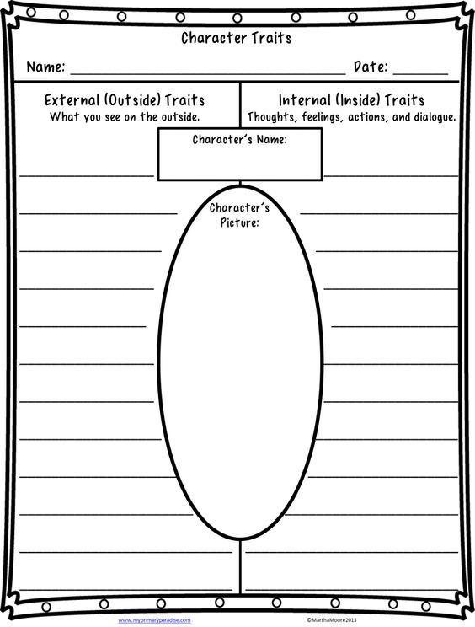

3. Hot-seating (at key points throughout)
I can show my understanding of what I listen to or watch by responding to literal, inferential, evaluative and other types of questions, and by asking different kinds of questions of my own. LIT 2-07a
When listening and talking with others for different purposes, I can: • share information, experiences and opinions • explain processes and ideas • identify issues raised and summarise main points or findings • clarify points by asking questions or by asking others to say more. LIT 2-09a
At key points in the book, the teacher can choose somebody to be interviewed as Janet and other characters, as if on TV or radio. This may involve dressing up with a key costume item or prop and if you have a spotlight available, it really helps to add to the occasion. The actor should improvise answers while classmates can create questions for the interview after the reading of the relevant chapters.

4. Creating the Writ (after Chapter 5)
I consider the impact that layout and presentation will have and can combine lettering, graphics and other features to engage my reader. LIT 2-24a
Having explored the elements which writers use in different genres, I can use what I learn to create stories, poems and plays with an interesting and appropriate structure, interesting characters and/or settings which come to life. ENG 2-31a
This may be suitable as a homework task. Pupils should create the writ on page 26, completing the text. Differentiation could allow some pupils to write it in modern English. The layout should be suitable for official document, but they should also make it look old-fashioned - think ribbons, wax seals/old-fashioned writing/quill and ink etc.
These could also be added to the class wall display.

5. Newspaper Front Page (after reading Chapter 11)
I am learning to use language and style in a way which engages and/or influences my reader. ENG 2-27a
I can convey information, describe events, explain processes or combine ideas in different ways. LIT 2-28a
I can persuade, argue, explore issues or express an opinion using relevant supporting detail and/or evidence. LIT 2-29a
By considering the type of text I am creating, I can select ideas and relevant information, organise these in an appropriate way for my purpose and use suitable vocabulary for my audience. LIT 2-26a
I consider the impact that layout and presentation will have and can combine lettering, graphics and other features to engage my reader. LIT 2-24a
On p.84, the Schoolmaster reads out snippets of the newspaper article about the revolt. The newspapers are reporting Ceannabeinne’s villagers in a negative light. Pupils should create the front page of the newspaper and write the headline and article, including the quotes the Schoolmaster reads out. They should imitate a newspaper layout and illustrate it. Maybe there is even room for an opinion column about the Clearances, or some 19th Century style adverts? Pupils can research these on the internet or create their own. Again, these pages make for a good addition to the class display. This task can be completed in groups to allow for co-operative learning and differentiation.

6. Diary Entry (after Chapter 14)
By considering the type of text I am creating, I can select ideas and relevant information, organise these in an appropriate way for my purpose and use suitable vocabulary for my audience. LIT 2-26a
I am learning to use language and style in a way which engages and/or influences my reader. ENG 2-27a
Pupils should write a diary entry for Janet or Angus, after they have returned from the ferry at Port Chamuil.

7. Animal Welfare Campaign (after Chapter 15)
Using what I know about the features of different types of texts, I can find, select and sort information from a variety of sources and use this for different purposes. LIT 2-14a
I can make notes, organise them under suitable headings and use them to understand information, develop my thinking, explore problems and create new texts, using my own words as appropriate. LIT 2-15a
Many readers are horrified by the flashback about the cat, but the incident features in historical eye-witness accounts, too. Sadly, animals are still mistreated today. Pupils should create a leaflet with relevant information, urging people to protect vulnerable animals. Useful sources of information and examples are listed here.
https://www.scottishspca.org/about/
http://www.mirror.co.uk/news/world-news/gang-kids-kick-flamingo-death-10025926
http://www.bbc.co.uk/news/uk-17821630
http://www.scotsman.com/news/animal-abuse-a-worrying-sign-1-951780

8. Speeches (after Chapter 23)
To help me develop an informed view, I can identify and explain the difference between fact and opinion, recognise when I am being influenced, and have assessed how useful and believable my sources are. LIT 2-18a
I can show my understanding of what I listen to or watch by responding to literal, inferential, evaluative and other types of questions, and by asking different kinds of questions of my own. LIT 2-07a
To help me develop an informed view, I can distinguish fact from opinion, and I am learning to recognise when my sources try to influence me and how useful these are. LIT 2-08a
‘He can make a speech, make no mistake!’ Pupils should read the Sheriff’s speech (p.174-176). What techniques are used to persuade? Pupils may also listen to or read other examples of persuasive speeches, e.g. Martin Luther King’s I have a dream speech, readily available on YouTube. They should list the techniques and then create a short persuasive speech on their own, using the same techniques (alliteration, addressing audience directly, quotes, repetition, lists of three, emotive vocabulary, promises, threats etc).

9. Mock Debate (at the end)
When I engage with others, I can respond in ways appropriate to my role, show that I value others’ contributions and use these to build on thinking. LIT 2-02a
I can make notes, organise them under suitable headings and use them to understand information, develop my thinking, explore problems and create new texts, using my own words as appropriate. LIT 2-15a
This can take place once the class have completed reading the novel. As per the character cards, the teacher should assign characters to willing actors and allow them a realistic amount of research/preparation time to debate the motion in character. The class should then vote and the motion should be declared ‘carried’ or ‘defeated’.
This house believes that the villagers of Ceannabeinne were WRONG to fight back against the clearance order.

10. Question-Time-style Panel (at the end)
When I engage with others, I can respond in ways appropriate to my role, show that I value others’ contributions and use these to build on thinking. LIT 2-02a
I can recognise how the features of spoken language can help in communication, and I can use what I learn. I can recognise different features of my own and others’ spoken language. ENG 2-03a
After completing the novel, pupils should use the character cards to prepare for a Question Time-style panel show. The whole class can prepare relevant questions while the chosen actors should anticipate likely questions and prepare answers consistent with their characters. It may help pupils to watch a short clip of the programme to familiarise themselves with the format. Filming the panel adds a sense of occasion, while any photographs taken can be added to the class display.

11. Photo Story Comic (at the end)
I can make notes, organise them under suitable headings and use them to understand information, develop my thinking, explore problems and create new texts, using my own words as appropriate. LIT 2-15a
Pupils should brainstorm the 10-12 main events in the novel Fir for Luck. Once they are in the right order, pupils can be given minimal dressing up/props and a camera to take freeze-frame photographs of these key dramatic moments.
Once printed, the photographs can be displayed with captions and speech bubbles. Don’t forget the sound effects either!

12. Multi-Generation Households
I am developing confidence when engaging with others within and beyond my place of learning. I can communicate in a clear, expressive way and I am learning to select and organise resources independently. LIT 2-10a / LIT 3-10a
Janet, her parents and her grandmother share the same house, and old and young share many experiences in Fir for Luck. They value each other and look out for one another. As a homework task, pupils should find an older person (a family member or a neighbour) and interview him/her about the way that life was more challenging in the past. They should feed their results back to class.
Class discussion: Watch https://www.facebook.com/worldeconomicforum/videos/10154162043261479/
Should we change the way we live in this country?

12. Clearances Ballad (at the end)
In both short and extended texts, I can use appropriate punctuation, vary my sentence structures and divide my work into paragraphs in a way that makes sense to my reader. LIT 2-22a
Having explored the elements which writers use in different genres, I can use what I learn to create stories, poems and plays with an interesting and appropriate structure, interesting characters and/or settings which come to life. ENG 2-31a
Ballads are poems/songs which tell a story.
Look at this example. It has 4 lines per stanza, the second and last lines rhyme and there is a regular rhythm (like a beat). It tells a story with a beginning, a middle and an end, and there is a lot of direct speech in it, too.
In pairs, have a go at creating a Highland Clearances ballad. It doesn’t have to be as long as this one.
The Dowie Dens of Yarrow
(Border Ballad, source https://mainlynorfolk.info/folk/songs/thedowiedensofyarrow.html )

1. There lived a lady in the north,
You could scarcely find her marrow,
She was courted by nine noblemen
And her ploughman boy o' Yarrow.
2. As he came ower yon high, high hills
And doon yon path sae narrow,
There he spied nine noblemen
For to fight with him on Yarrow.
3. As he came ower yon high, high hills
And doon yon path sae narrow,
There he spied nine noblemen
For to fight with him on Yarrow.
3. There was three he slew and three withdrew,
And three lay deadly wounded,
Till her brother John stepped in behind+
And pierced his body through.”
4. “Go home, go home, you false young man,
And tell your sister sorrow,
That her true-love John lies dead and gone
In the dowie dens o' Yarrow.”
5. As he gaed ower yon high, high hills
And doon yon path sae narrow,
There he spied his sister dear
She was coming fast for Yarrow.”
6. “Oh, brother dear, I've dreamt a dream
And I hope it will not prove sorrow.
I dreamt that you were spilling blood
In the dowie dens o' Yarrow.”

7. “Oh, sister dear, I'll read your dream
And I'm sure it will prove sorrow.
Your true-love John lies dead and gone
And a bloody corpse on Yarrow.”
8. Now this fair maid's hair was three-quarters long
And the colour of it was yellow.
She tied it roond his middle small,
As she's carried him hame tae Yarrow.
9. “Oh, daughter dear, dry up your tear
And dwell no more in sorrow,
For I'll wed you to far higher degree
Than your ploughman boy o' Yarrow.”
10. “Oh, father dear, you have seven sons,
You can wed them all tomorrow.
But a fairer floo'er there never bloomed
Than my ploughman boy o' Yarrow.”

13. Amazon Book Review (at the end)
I enjoy creating texts of my choice and I regularly select subject, purpose, format and resources to suit the needs of my audience. LIT 1-20a / LIT 2-20a
Pupils should write a short online book review to post up on Amazon, Waterstones and/or Goodreads. They should check their work throughout the process, making sure that it makes sense at first reading.

14. Top Trumps Cards (at the end)
I enjoy creating texts of my choice and I regularly select subject, purpose, format and resources to suit the needs of my audience. LIT 1-20a / LIT 2-20a
Pupils should list as many characters as they can for Fir for Luck. Using their own judgment about format, allow each group to create a Top Trumps card game. Each character should get a score for four categories. Possible categories include:

Courage
Strength,
Wisdom
Kindness
Wealth
Likeability

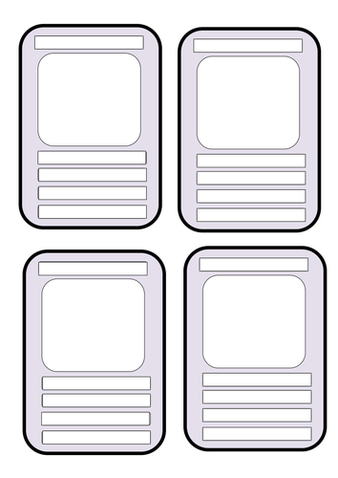Source TES. Image can be enlarged.

