Teaching Resources/BGE
Punch
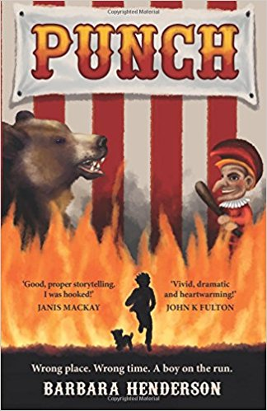

By Barbara Henderson
Before you begin…
Homework Task
1. Search for images of Victorian Scotland. You may even find images of the place where you live, of famous Victorians, Victorian clothes, transport, entertainment…
Photography was becoming popular, but you might also find paintings/illustrations etc. Bring an image to school to create a class collage for your unit.
2. Research the Victorian Scotland online or at a library. Write down three facts, a sentence for each. Be sure to use correct punctuation and spelling.

At School
1. Got your pictures?
Assemble the images into a display. This will serve as a heading for further work you create as a class.
2. What do we already know about Victorian Times?
Each pupil can now share one interesting fact from their research. Avoid repeating the same information.
All of this will serve as a background to your study of Punch.

3. Let’s get our bearings, shall we? Here are three extracts of a map, produced in 1889, the very year our story is set.
Source: https://maps.nls.uk/view/142841859 John Bartholomew & Co., Sportsman's & tourist's guide map of Scotland, Edinburgh: J. Bartholomew & Co., 1889
Mark the locations of the story: Inverness, Loch Ness, Fort Augustus, Perth, Balmoral, the Fife Coast, Edinburgh.
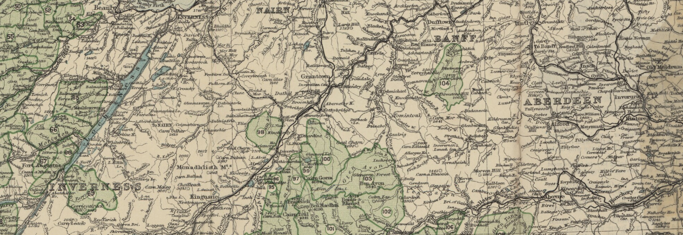
Figure 1 Find Inverness, Loch Ness, Fort Augustus, Balmoral
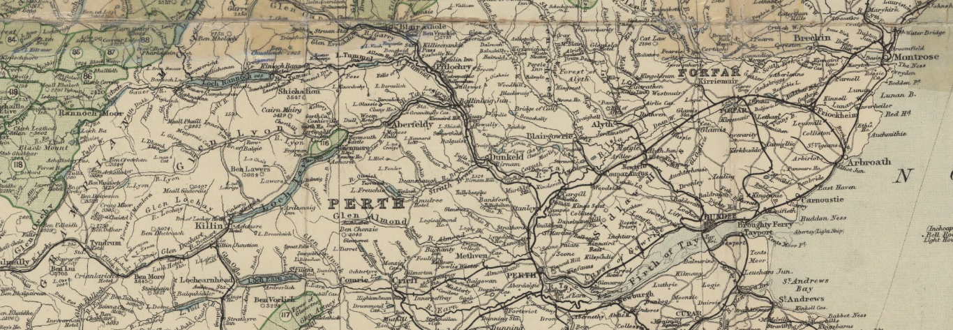
Figure 2 Find Perth
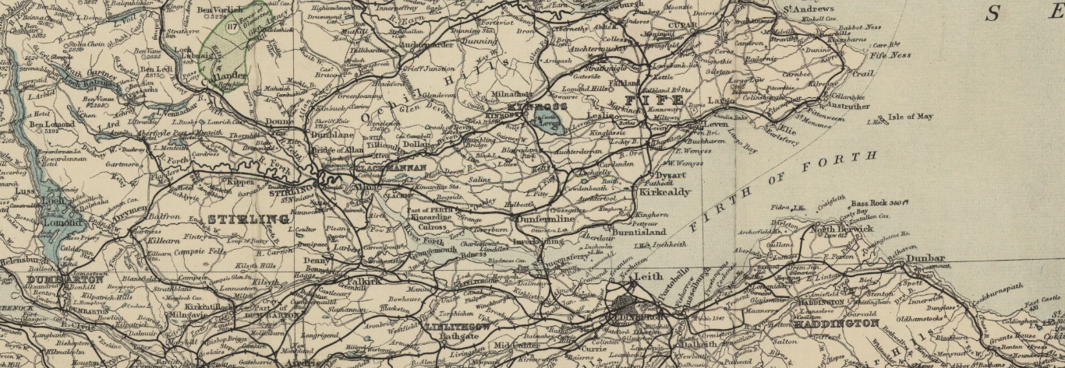
Figure 3 Find the Fife Coast and Edinburgh
Questions for Discussion to accompany each chapter.
Through developing my knowledge of context clues, punctuation, grammar and layout, I can read unfamiliar texts with increasing fluency, understanding and expression. ENG 2-12a / ENG 3-12a / ENG 4-12a
Using what I know about the features of different types of texts, I can find, select and sort information from a variety of sources and use this for different purposes. LIT 2-14a/ Using what I know about the features of different types of texts, I can find, select, sort, summarise, link and use information from different sources. LIT 3-14a / LIT 4-14a
To show my understanding across different areas of learning, I can identify and consider the purpose and main ideas of a text and use supporting detail. LIT 2-16a/ To show my understanding across different areas of learning, I can: • identify and consider the purpose, main concerns or concepts and use supporting detail • make inferences from key statements • identify and discuss similarities and differences between different types of text. LIT 3-16a
To show my understanding, I can respond to literal, inferential and evaluative questions and other close reading tasks and can create different kinds of questions of my own. ENG 2-17a/ To show my understanding, I can comment, with evidence, on the content and form of short and extended texts, and respond to literal, inferential and evaluative questions and other types of close reading tasks. ENG 3-17a

Chapter 1 Inverness, 1889: The Market at Night
- ‘Hands the size of spades shake me roughly awake’
What does this suggest about how the narrator is feeling about the night visitor to his chamber?
- ‘I’d rather not imagine what Uncle Ewan’s spade hands would do if his sausages weren’t delivered.’ What is Phineas scared of?
- ‘All the paper bags dance with flames.’ What type of image is being used here? What does it suggest?
- ‘WHAT HAVE YOU DONE, BOY? YOU’VE SET THE MARKET ON FIRE!’ How do you feel about what the night guard is doing? What might be his reasons for blaming Phineas?
Chapter 2 Run, Phineas
- ‘I look away and make a perfectly folded parcel of sausages in my hands’ Why can’t Phineas bear to look?
- Find two quotes as evidence that Phineas is confused or distressed.
- ‘The whole Market is burning, as if the devil himself had struck the match’ This is religious language. What does it suggest about how ferocious the fire is?
- ‘Hypnotised by the fire, I banish all thoughts of tomorrow. I stay because I have nowhere to go. I’m silent because I have nothing to say and no-one to say it to.’ How would you describe Phineas’ mood at this point?
- ‘Through the dense needled branches, I recognise the subtle stripes of a prisoner’s clothes.’ This is a cliff-hanger ending. Why is ‘cliff-hanger’ a good name for this technique? How does it make the reader feel?
Chapter 3 The Ruffian
- Write a definition of the word ‘ruffian’.
- How would you describe the prisoner in three words not used in the text?
- Find an example of the prisoner using Scots dialect. What does his language imply about his character?
- ‘They’re my father’s boots, I want to shout. It’s all I have left’ Why doesn’t Phin put up more of a fight? And why are the boots so special to him?
Chapter 4 The Travellers
- ‘Oh Lord, did I just say that aloud?’
*When the character speaks to himself in his thoughts, it’s called ‘interior monologue’. Find another example of it in this chapter.
- How does Phineas feel about the prisoner in this chapter? Find evidence for your choice.
- ‘Professor Moffat’s Entertainment’. In Victorian Times, many showmen and entertainers called themselves ‘Professor. How do we use the word now?
- ‘The woman looks shocked. ‘But what about that fugitive? Haven’t you heard? It's not safe out there. Not when there's a violent villain on the loose. They say he was awaiting trial for attempted murder, he was. And he escaped.’ What do we as readers know that the woman doesn’t realise right now?
*When readers know more than the characters, it’s called ‘dramatic irony’ – a useful term you can impress your teacher with!
Chapter 5 Phin
- ‘Attempted murder.’ How do you feel about Mr Robertson now that you have this information?
- Find the sentence on p. 27 which shows that Phin is suspicious of the entertainers, too.
- ‘Behaving properly was more important than religion in Uncle Ewan’s house. Which is why my sister Lizzie was never talked about at all. What might be the reason Lizzie disappeared?
- How does the narrator feel about being called Phin? P.30/31 might give you some clues.
- Another cliff-hanger: Why is Phin sending up ‘a split-second prayer’?
Chapter 6 Kindness from Unexpected Places
- Why is Mr Robertson’s action at the beginning of the chapter surprising?
- Why does Phin have the sudden urge to laugh? What about this situation is funny?
- What does Phin mean by ‘Trapped animals are most dangerous of all; everyone knows that.’ How is Mr Robertson like a trapped animal at this point?
Chapter 7 An Honest Man
- The Moffat family react unexpectedly when told the truth. How would you describe their attitude towards Phin and Mr Robertson?
- ‘It’s lovely and new: that someone should take my side.’ Why does Phin deserve some good luck?
- Read the description of the inside of the caravan on p.40? What clues about the Moffat family can you find in there?
- Why do Mr Robertson’s eyes ping wide, wide open? Is there a change of atmosphere? If so, how would you describe it?
Chapter 8 The Bonnet and the Blanket
- Mr Robertson pretends to be a woman. Can you think of any other stories/films where a man disguises himself as a woman to keep safe, or for humorous purposes?
- How does Professor Moffat avert a crisis in this chapter?
- Name two ways in which Phin’s and Izzie’s lives have been different so far.
Chapter 9 The Art of Screaming
- What does Professor Moffat mean by ‘an asset to our act’?
- ‘He holds them like they’re sacred.’ – What type of imagery is used here? What does it suggest about how Professor Moffat feels about his job?
- Look at the last sentence in the chapter. How would you describe the Moffats’ attitude to Phin as he is learning?
Chapter 10 One of Those Moments
- Write down one new thing you have learned about Victorian puppetry in this chapter.
- ‘The Professor tells me story after story and I drink them in’ What type of imagery is used here? What does this choice suggest about how Phin feels about the stories he is told?
- ‘One day you’ll tell us your whole story, will you?’ What questions do we as readers still have about Mr Robertson?
- ‘He smiles down at me with something that looks like pride’ Complete the sentence: Professor Moffat is beginning to treat Phin as part of the _____________?
Chapter 11 Nothing out of the Ordinary
- Find evidence on p. 59 that Ishie is worried about her father.
- Why do you think we react so strongly to cruelty to animals?
- Why is it dangerous to enter a river in the dark? And why does Phin do it anyway? What would you risk your life for?
- ‘The river tears at its prey.’ What does this suggest about how much power Phin has in this situation?
- ‘What have I done? (p,63)’ Have you ever done anything that you didn’t think through? Or regretted a decision you have made? Tell your group about it briefly.
Chapter 12 The Mysterious Mission
- Why is Mr Robertson’s reaction so unexpected?
- ‘Nothing can dampen Merriweather Moffat’s mood today. What does the name suggest about Professor Moffat’s character?
*When words or stressed syllables begin with the same sound, it’s called ‘alliteration’. Can you spot this technique in this sentence?
- ‘I shake my head to forget, like I ran to forget, too. Now I play fiddle to forget. As soon as the curtain opens, I wriggle my hands for Judy and the Devil and the Policeman and the Toby-dog. To forget.’? What phrase is repeated? What is the effect of this repetition? What does it suggest about the thing he is trying to put behind him?
- What is your reaction to the final line in the chapter? What questions do you have?
Chapter 13 An Asset to our Act
- ‘Professor Moffat does not take his eyes of the bear. ‘There is something wrong with the beast, listen!’ What does the showman think is wrong? What is the truth?
- ‘There is something I am obliged to say.’ Why does Phin ‘feel sick’ at Professor Moffat’s words?
- What does the showman want to do with Phin’s puppy? Why is this a good solution?
Chapter 14 The Name Game
- ‘Ishie smiles and hands the quill back to me, but slowly, as if her fingers didn’t want to let go of the feather just yet? How does she feel about learning to write, do you think? Do you remember a time in the book when she said it didn’t matter that she never went to school? Do you think it’s important to be able to read and write? And why?
- ‘Look at this majestic creature; really look. Take it all in: the shiny fur. The imposing stance, the rippling muscles, the wild eyes. The savage mouth, the fettered power. He needs a NAME. A magic name, a majestic name. Something that heralds: Here is the most awe-inspiring dancing bear in Scotland!’’ Choose three adjectives to describe the Professor’s voice when he says this. How do you imagine it?
- What questions do you have after the cliff-hanger at the end of this chapter? What do you predict will happen next?
Chapter 15 Punch
- At the beginning of this chapter there is a contrast. How would you describe Professor Moffat’s mod? And Phin’s mood? Fin one quote as evidence for each.
- Why is Phin’s performance better than usual?
- The flashback in this chapter doesn’t make for easy reading. Sum up what happens in it in one sentence. Does it help you understand the story better?
- ‘Until I have Toby clutched to my chest’ – having a pet does often help in difficult times. Where do you go, and what do you do to help you cope with challenging situations?
Chapter 16 Things That Happened and Things That Didn’t
- Find two words/phrases in this chapter which show that Mr Robertson is kind to Phin.
- ‘Fire-raiser, runaway, ungrateful ward, almost thirteen years of age and of a deceptive, most malevolent nature.’ Is this a fair assessment of Phin? Why/why not?
- Why does the reward money make a difference to Phin? And why do you think Uncle Ewan is so keen to get Phin back?
- Why is ‘They are upon me’ an effective ending to the chapter?
Chapter 17 No Need to Run
- Not to him! Never to him.’ What do you think would happen if Phin was caught and returned to Inverness?
- How does the writer create sympathy for Phin in this chapter?
- Why is the new leaflet a serious danger to Mr Robertson?
- The atmosphere at the very end of the chapter has changed. How would you describe it at the beginning and at the end? Find one quote each to back up your answers.
Chapter 18 Merriweather Moffat’s Ambition
- In your own words, give two reasons why the Moffats want to keep Phin and Mr Robertson.
- Look up a definition of ‘Highland Games’ – what happens at such an event?
- Phin is teaching Ishie to read and write. What skill would you like to learn? Is there anyone who could teach you?
- Merriweather Moffat keeps dropping hints, but is enjoying keeping the details of the trip secret. Have you come across this kind of behaviour before? Why is he delaying telling them the whole truth?
Chapter 19 A Real Live Dog Toby
- ‘The Queen of the Great British Empire, in a place like this? It simply doesn’t seem possible.’ What type of place would be more suitable for the Queen?
- ‘I’ve sort of had an idea. About the script. Would you like to hear it?’
To my astonishment, Professor Moffat would. Why is this surprising? Does it make you like Professor Moffat?
- Do you think it’s fair that Toby is going to be trained for the performance?
Chapter 20 The Big Day
- ‘This may be a village performance, but with a London audience, spoilt by the famous Mr Wilde’s West End theatre productions. A wave of nausea washes over me.’ What does this imply about the audience’s expectations?
- Phin resents wearing the smart clothes. Can you think of a modern context where you have to dress smart? What are the reasons for this, do you think?
- ‘I have an ill-feeling about this.’ What effect does this final sentence have on the reader?
Chapter 21 Mr Robertson’s Ill Feeling
- There is a lot of description in this chapter to capture the atmosphere of the event. Many details are taken from a contemporary newspaper article and are accurate. Can you imagine the scene? What is the most interesting thing to you?
- Was Mr Robertson’s ‘ill feeling’ justified? What goes wrong in this chapter?
Chapter 22 The Royal Pavilion
- ‘There is doubtless joy…’ Why is Phin enjoying this performance so much?
- There is a strong contrast in this chapter. How is Phin feeling, and why? What about Ishie? How are the friends supporting each other in this chapter? Do you find it easy to be supportive of others?
Chapter 23 Whisky
- What triggers Phin’s flashback in this chapter? What reminds him of the past?
- The flashback is written in italics. Why do you think that choice has been made?
- Does the new information change or confirm how you feel about Uncle Ewan? Why did he offer to look after Phin as a young boy?
- Is the ending of this chapter effective? Why/ why not?
Chapter 24 The Hunt
- This is quite a tense part of the book. Draw a basic graph, numbers 1-10 for tension up the left-hand side, with ten being the tensest, and zero being not tense at all, rate the tension at the following points over the next three chapters:
- P.128: My heart beats faster than Punch’s baby’s rattle. Deep, deep breaths, Phineas, there’s nothing to be gained by having a heart attack. (__/10)
- P.129: ‘Dear. Is it perhaps wise to wait until morning?’ (__/10)
Chapter 25 A Shape in the Night
- P.132: No birdsong, no hoofbeats on the road, and very little light, for the moon is a narrow slither, often obscured by passing clouds. A knot begins to form in my stomach. (__/10)
- P.133: My eyelids begin to droop. (__/10)
- P.133: ‘Phineas! Phineas! Wake up!’ (__/10)
- P.133: ‘We have to set the horse loose,’ Ishie whispers in a horrified croak. (__/10)
- P.135: Now there is nothing between The Bruce and me; nothing AT ALL. The bear’s eyes glint whenever the moonlight catches it. (__/10)
- P.133: He charges. (__/10)
Chapter 26 Boy Versus Bear
- P.136: I find myself sprinting full pelt towards his cage. (__/10)
- P.137: Both Ishie and I stand statue-still. The Bruce is out of sight, but we can hear his snorting and chewing. He seems to be getting closer. (__/10)
- P. p.137: The Bruce lifts his head and sniffs intently. Oh no. The wind has turned. (__/10)
- P.138: I curse myself for being so stupid. That’s why the Bruce escaped in the first place. (__/10)
- P.139: She hobbles away without even saying goodnight and I hear no noise from the caravan. (__/10)
- P.140: …the expression on the adults’ faces is priceless. (__/10)
Chapter 27 The Reward
- Why is Phineas distressed to be offered new boots on page 142?
- How is Mr Robertson feeling on page 143? Give reasons for your choice.
- Is the present which Phin receives at the end of the chapter a good one? Why? What is the best thing anyone could give you right now?
Chapter 28 Balmoral
- This chapter is a wee bit humorous. How is the light-hearted tone achieved?
- Queen Victoria makes an appearance in this chapter. What is the most memorable thing about this character for you? Does anything surprise you?
- Why does Professor Moffat think that ‘this changes everything’? What is he hoping the reference will achieve?
Chapter 29 The Highland and the Lowland Ways
- Why is Mr Robertson’s sign a good thank-you gift?
- What does Phin mean when he uses the metaphors ‘My world is a rainbow. His is a shadow’?
- Charles Dickens’ A Christmas Carol was already a bestseller in Phin’s time. Write a sentence, summing up what the book is about. You may need to research this.

Chapter 30 Morningside
- Make a list of the places and streets in Edinburgh which are mentioned here.
- Choose three adjectives to describe Professor Moffat in this chapter.
- Who do you think is chasing Phin at the end of the chapter?
Chapter 31 Alive and Well
- Why would the son of a Highland Reverend not be a travelling showman if all was well? How do you think Phin’s father would feel about the job Phineas is doing?
- Why does Mr Robertson want to come with Phin?
- When Phin hears shouts of ‘Police!’ in the street, what does he fear?
Chapter 32 Bounty Hunters
- There is a lot of direct speech in is chapter. Write down an example.
- Page 176 finally gives us some clues about what happened to Mr Robertson before Phin met him. Sum the story up in your own words.
- Why is there hope now? What has changed for Mr Robertson?
Chapter 33 The Return
- Explain what is meant by ‘a whirlpool of worries swirls in my mind’ (p.177).
- Hiding behind starched collars and under top hats (p.179) What impression are they trying to give?
- Why is Phin so distraught that the woman was Miss Garrow?
Chapter 34 The Showdown
- Explain in your own voice how Phin and Professor Moffat are using the Puppet show in this chapter.
- Page 184: I’d know those hands anywhere. Whose hands are they? Can you think of another part of the book where these hands are mentioned?
- Why would Mr Robertson choose to hand himself in, after all he has been through?
Chapter 35 A New Market
- Why do you think they have all travelled up to meet Miss Garrow on her release from prison?
- Look at the simile on page 191. What does the tapestry image suggest about Phin’s life now?
- Do you think that Mr Robertson’s errand makes a fitting ending to the story? Why/why not?
Author’s Note
Do read through this. It may be interesting for you to read how the story formed in the mind of the author.

Tasks
1. Reading the text and discussing the questions (throughout) as above.
Through developing my knowledge of context clues, punctuation, grammar and layout, I can read unfamiliar texts with increasing fluency, understanding and expression. ENG 2-12a / ENG 3-12a / ENG 4-12a
Using what I know about the features of different types of texts, I can find, select and sort information from a variety of sources and use this for different purposes. LIT 2-14a/ Using what I know about the features of different types of texts, I can find, select, sort, summarise, link and use information from different sources. LIT 3-14a / LIT 4-14a
To show my understanding across different areas of learning, I can identify and consider the purpose and main ideas of a text and use supporting detail. LIT 2-16a/ To show my understanding across different areas of learning, I can: • identify and consider the purpose, main concerns or concepts and use supporting detail • make inferences from key statements • identify and discuss similarities and differences between different types of text. LIT 3-16a
To show my understanding, I can respond to literal, inferential and evaluative questions and other close reading tasks and can create different kinds of questions of my own. ENG 2-17a/ To show my understanding, I can comment, with evidence, on the content and form of short and extended texts, and respond to literal, inferential and evaluative questions and other types of close reading tasks. ENG 3-17a
2. Character cards (throughout)
I can make notes, organise them under suitable headings and use them to understand information, develop my thinking, explore problems and create new texts, using my own words as appropriate. LIT 2-15a/ I can make notes and organise them to develop my thinking, help retain and recall information, explore issues and create new texts, using my own words as appropriate. LIT 3-15a / LIT 4-15a
At the end of each chapter, pupils should add information to the character cards. Any new information or quotes build up a picture and also prepare pupils for the debate/question time panel at the end. The best ones should be displayed under the classroom heading.
A suggestion for a possible layout is included, but pupils may want to create their own layout, and use the back of the card for quotes and page references. The more detail they add to these cards during the reading, the easier the tasks at the end will be.
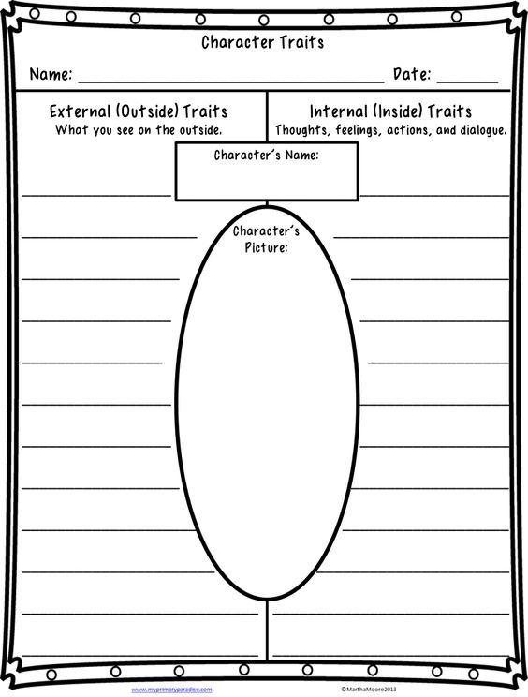

3. Hot-seating (at key points throughout)
I can show my understanding of what I listen to or watch by responding to literal, inferential, evaluative and other types of questions, and by asking different kinds of questions of my own. LIT 2-07a I can show my understanding of what I listen to or watch by commenting, with evidence, on the content and form of short and extended texts. LIT 3-07a
When listening and talking with others for different purposes, I can: • share information, experiences and opinions • explain processes and ideas • identify issues raised and summarise main points or findings • clarify points by asking questions or by asking others to say more. LIT 2-09a When listening and talking with others for different purposes, I can: • communicate information, ideas or opinions • explain processes, concepts or ideas • identify issues raised, summarise findings or draw conclusions. LIT 3-09a
At key points in the book, the teacher can choose somebody to be interviewed as Phin and other characters, as if on TV or radio. This may involve dressing up with a key costume item or prop and if you have a spotlight available, it really helps to add to the occasion. The actor should improvise answers while classmates can create questions for the interview after the reading of the relevant chapters. A special chair and a spotlight on it can add a sense of occasion, as can a jingle, played before each hot-seating session.
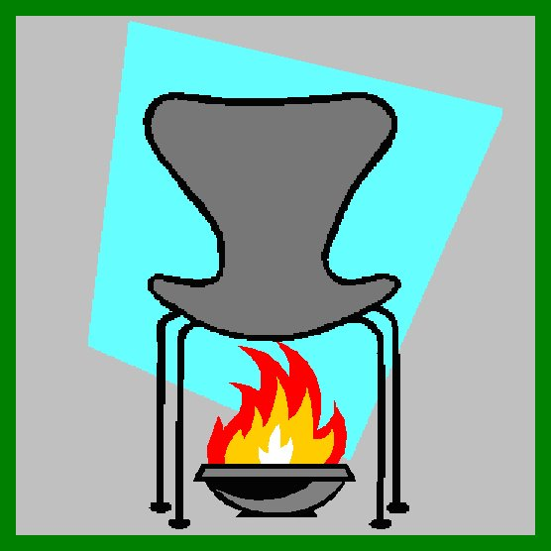
4. Comic of Chapter 1
By considering the type of text I am creating, I can select ideas and relevant information, organise these in an appropriate way for my purpose and use suitable vocabulary for my audience. LIT 2-26a By considering the type of text I am creating, I can independently select ideas and relevant information for different purposes, and organise essential information or ideas and any supporting detail in a logical order. I can use suitable vocabulary to communicate effectively with my audience. LIT 3-26a / LIT 4-26a
Create a template for a comic, along the lines of this. Capture the key moments of the exciting opening chapter, adding speech bubbles and sounds in your own words. The more colourful and attractive your pictures the better!
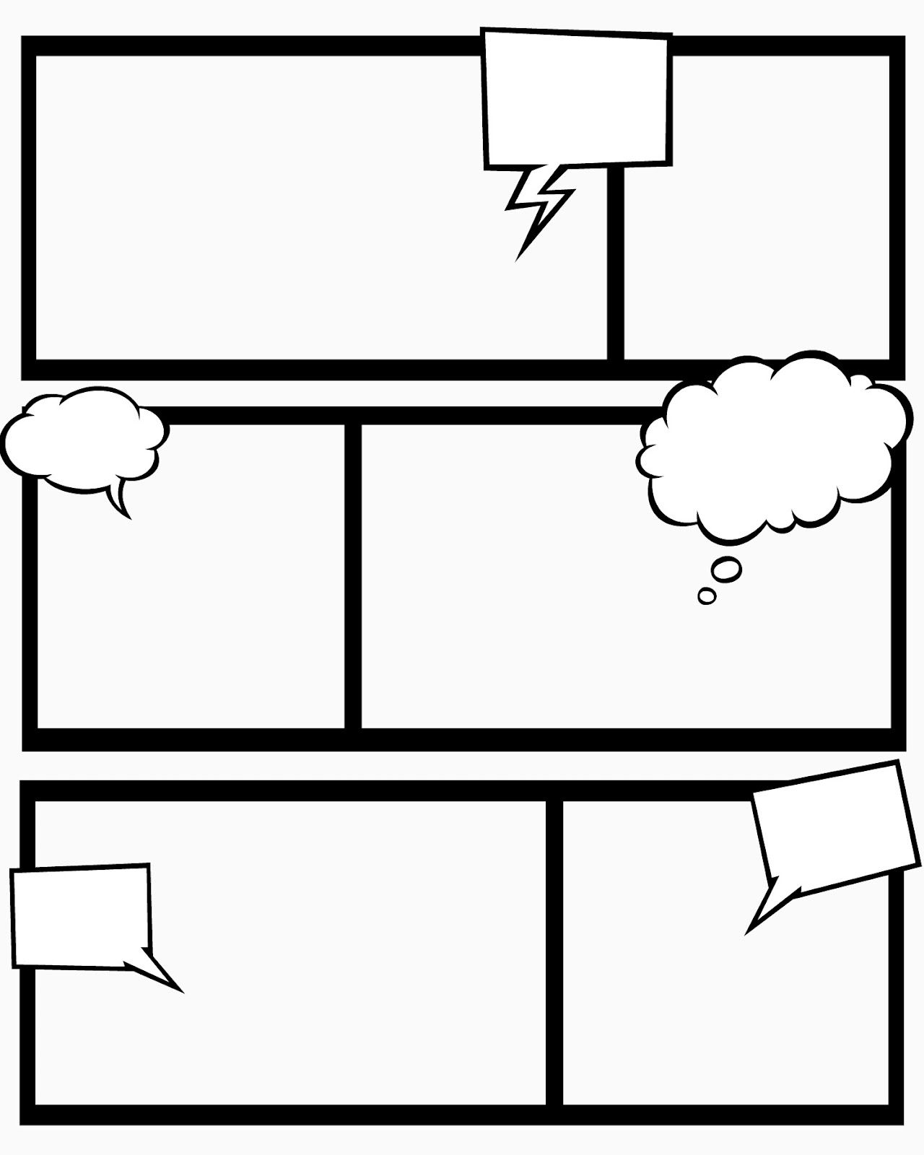
5. Newspaper Front Page (after reading Chapter 4)
I am learning to use language and style in a way which engages and/or influences my reader. ENG 2-27a I can engage and/or influence readers through my use of language, style and tone as appropriate to genre. ENG 3-27a / ENG 4-27a
I can convey information, describe events, explain processes or combine ideas in different ways. LIT 2-28a I can convey information, describe events, explain processes or concepts, and combine ideas in different ways. LIT 3-28a
I can persuade, argue, explore issues or express an opinion using relevant supporting detail and/or evidence. LIT 2-29a I can persuade, argue, evaluate, explore issues or express an opinion using a clear line of thought, relevant supporting detail and/or evidence. LIT 3-29a
By considering the type of text I am creating, I can select ideas and relevant information, organise these in an appropriate way for my purpose and use suitable vocabulary for my audience. LIT 2-26a By considering the type of text I am creating, I can independently select ideas and relevant information for different purposes, and organise essential information or ideas and any supporting detail in a logical order. I can use suitable vocabulary to communicate effectively with my audience. LIT 3-26a / LIT 4-26a
I consider the impact that layout and presentation will have and can combine lettering, graphics and other features to engage my reader. LIT 2-24a I can consider the impact that layout and presentation will have on my reader, selecting and using a variety of features appropriate to purpose and audience. LIT 3-24a
The fire in the Market made headline news. Pupils should create the front page of the newspaper (give it suitably Highland Scottish name) and write the headline and article, including quotes from key characters like Young MacLennan and Butcher Ewan Finlayson. They should imitate a newspaper layout and illustrate it. Maybe there is even room for an opinion column, or some 19th Century style adverts? Pupils can research these on the internet or create their own. Again, these pages make for a good addition to the class display. The task can be completed in groups to allow for co-operative learning and differentiation.
5. Creating the Wooden Sign (after reading chapter 14)
I consider the impact that layout and presentation will have and can combine lettering, graphics and other features to engage my reader. LIT 2-24a I can consider the impact that layout and presentation will have on my reader, selecting and using a variety of features appropriate to purpose and audience. LIT 3-24a
Use a flat piece of wood and give it a base coat in a bright colour before recreating Phin’s wooden sign on page 79. Include the drawing of a bear and use attractive lettering suitable for a circus. If you can, use metal chain to hang it to make it look authentic! These make wonderful classroom displays!

6. Creating the Pamphlet (after reading chapter 16)
I consider the impact that layout and presentation will have and can combine lettering, graphics and other features to engage my reader. LIT 2-24a I can consider the impact that layout and presentation will have on my reader, selecting and using a variety of features appropriate to purpose and audience. LIT 3-24a
Having explored the elements which writers use, I can create texts in different genres by: • integrating the conventions of my chosen genre successfully and/or • using convincing and appropriate structures and/or • creating interesting and convincing characters and/or • building convincing settings which come to life. ENG 3-31a
This may be suitable as a homework or class task. Pupils should create the pamphlet on page 88/89, completing the text of which snippets are given in the book. Differentiation could allow some pupils to write it in modern English. The layout should be suitable for an information leaflet, but it should also look old-fashioned - think fonts, wax seals/old-fashioned writing/quill and ink, ink drawings etc.
These could also be added to the class wall display.

7. Animal Welfare Campaign (after Chapter 15)
Using what I know about the features of different types of texts, I can find, select and sort information from a variety of sources and use this for different purposes. LIT 2-14a Using what I know about the features of different types of texts, I can find, select, sort, summarise, link and use information from different sources. LIT 3-14a
I can make notes, organise them under suitable headings and use them to understand information, develop my thinking, explore problems and create new texts, using my own words as appropriate. LIT 2-15a I can make notes and organise them to develop my thinking, help retain and recall information, explore issues and create new texts, using my own words as appropriate. LIT 3-15a / LIT 4-15a
When Merriweather Moffat returns, his face beams once more. ‘The bear truly is an asset. He is a marvel, and more than a match for any dancing bears the Queen may have seen, for so many such beasts are ill-treated, and the Queen is most compassionate to the welfare of all God’s creatures.’
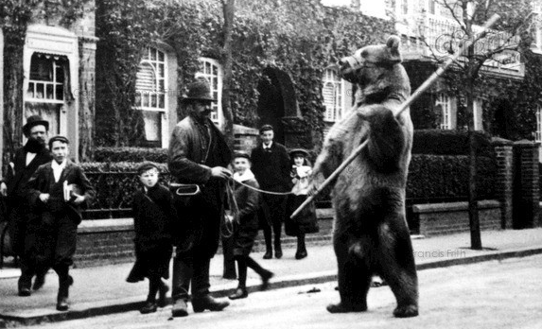
Figure 4 Source unknown
Queen Victoria was the patron of the newly formed RSPCA. Find out what the letters stand for. She cared about animals.
Find out why dancing bears were often cruelly treated.
Sadly, bears are still mistreated today in some parts of the world. Pupils should create a leaflet with relevant information, urging people to protect vulnerable animals. Useful sources of information and examples are listed here.
https://www.scottishspca.org/about/
http://www.mirror.co.uk/news/world-news/gang-kids-kick-flaming
http://www.bbc.co.uk/news/uk-17821630
http://www.scotsman.com/news/animal-abuse-a-worrying-sign-1-951780
o-death-10025926
6. Diary Entry (after Chapter 27)
By considering the type of text I am creating, I can select ideas and relevant information, organise these in an appropriate way for my purpose and use suitable vocabulary for my audience. LIT 2-26a By considering the type of text I am creating, I can independently select ideas and relevant information for different purposes, and organise essential information or ideas and any supporting detail in a logical order. I can use suitable vocabulary to communicate effectively with my audience. LIT 3-26a / LIT 4-26a
I am learning to use language and style in a way which engages and/or influences my reader. ENG 2-27a I can engage and/or influence readers through my use of language, style and tone as appropriate to genre. ENG 3-27a / ENG 4-27a
Pupils should write a diary entry for either Phineas, Ishie, Mr Robertson or Merriweather Moffat, after the bear has been recaptured.
9. Mock Debate about Animals in Circuses
When I engage with others, I can respond in ways appropriate to my role, show that I value others’ contributions and use these to build on thinking. LIT 2-02a When I engage with others, I can make a relevant contribution, encourage others to contribute and acknowledge that they have the right to hold a different opinion. I can respond in ways appropriate to my role and use contributions to reflect on, clarify or adapt thinking. LIT 3-02a
I can make notes and organise them to develop my thinking, help retain and recall information, explore issues and create new texts, using my own words as appropriate. LIT 3-15a / LIT 4-15a
This can take place after the class have completed reading the novel. Allow pupils a realistic amount of research/preparation time to debate the motion. If the class is able, assign specific roles such as chair, proponent, opponent and seconders who speak before opening the debate to the floor. After a set amount of time, the class should then vote and the motion should be declared ‘carried’ or ‘defeated’.
This house believes that it is cruel to make animals perform in a circus.

10. Question-Time-style Panel (at the end)
When I engage with others, I can respond in ways appropriate to my role, show that I value others’ contributions and use these to build on thinking. LIT 2-02a When I engage with others, I can make a relevant contribution, encourage others to contribute and acknowledge that they have the right to hold a different opinion. I can respond in ways appropriate to my role and use contributions to reflect on, clarify or adapt thinking. LIT 3-02a
I can recognise how the features of spoken language can help in communication, and I can use what I learn. I can recognise different features of my own and others’ spoken language. ENG 2-03a Having explored and analysed the features of spoken language, I can use these, adopting an appropriate register to suit my purpose and audience. ENG 3-03a
After completing the novel, pupils should use the character cards to prepare for a Question Time-style panel show. The whole class can prepare relevant questions while the chosen actors should anticipate likely questions and prepare answers consistent with their characters. It may help pupils to watch a short clip of the programme to familiarise themselves with the format, and other formats can also be chosen (chat show etc – whatever pupils are likely to engage with. Play a familiar jingle if you can!). Filming the panel adds a sense of occasion, while any photographs taken can be added to the class display.
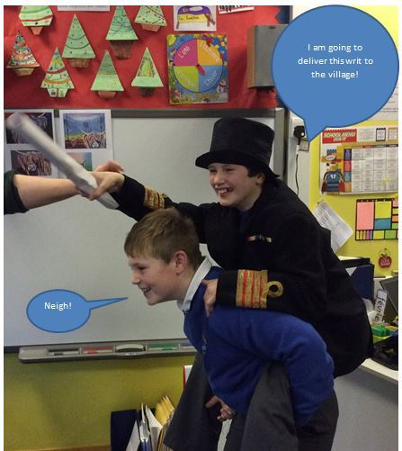
11. Photo Story Comic (at the end)
I can make notes, organise them under suitable headings and use them to understand information, develop my thinking, explore problems and create new texts, using my own words as appropriate. LIT 2-15a I can make notes and organise them to develop my thinking, help retain and recall information, explore issues and create new texts, using my own words as appropriate. LIT 3-15a / LIT 4-15a
Pupils should brainstorm the 10-12 main events in the novel Punch. Once they are in the right order, pupils can be given minimal dressing up/props and a camera to take freeze-frame photographs of these key dramatic moments.
Once printed, the photographs can be displayed with captions and speech bubbles. Don’t forget the sound effects either!

12. Giant Punch and Judy Show
I have experienced the energy and excitement of presenting/performing for audiences and being part of an audience for other people’s presentations/performances. EXA 2-01a I have used the skills I have developed in the expressive arts to contribute to a public presentation/performance. EXA 3-01a
If you do not have a set of traditional Punch and Judy Puppets, make your show BIGGER! A basic prop or costume for each character, plus an inflatable club for Punch to hit people with, is all you need. Two kids can hold a sheet of fabric behind which the ‘puppets’ pop up. Children will pop and down as you direct, and a tambourine or cymbal works wonders at the BANG moments.

The basic story can go like this:
Basic skeleton script:
You (as narrator): There was once a bad man called Mr Punch (tell kid to pop up). He always had a club with which he could hit people when they annoyed him – not a good idea! One day Judy came (does) and told Mr Punch: Look after the baby! (girl repeats this loudly, baby pops up). But Mr Punch said NO (does) and Judy said YES (does). So Judy pushed the baby towards Mr Punch (act this out) and left. (Judy pops back down behind sheet). The baby began to cry (does). Mr Punch said: BABY, be quiet. But the baby cried louder, and louder. Mr Punch tried to hold his ears shut, but the baby cried so loudly that Mr Punch raised his club and BANG! (baby disappears) And that was the end of the baby.
Judy came back and said Where is my BABY? Mr Punch said I don’t know.
Where is my Baby, Judy repeated and Mr Punch raises his big club and Bang! That was the end of Judy. A Policeman came and said: Mr Punch you are a bad man. I will have to arrest you. And Mr Punch raised his big club and BANG, that was the end of the policeman. And then the Queen Victoria came and said in a very posh voice: Mr Punch, you simply cannot behave like this in my kingdom! I shall have you…
But Mr Punch raised his big club and BANG! That was the end of the Queen. So the Executioner came, holding his big scythe. Uh-oh. That’s a good weapon you have there, said Mr Punch. May I have a look? And he raised his big club and BANG, the end of the executioner. But in Victorian times, the Devil would pop up at the end and drag Mr Punch down with him.
And that, ladies and gentlemen, was the end of Mr Punch!
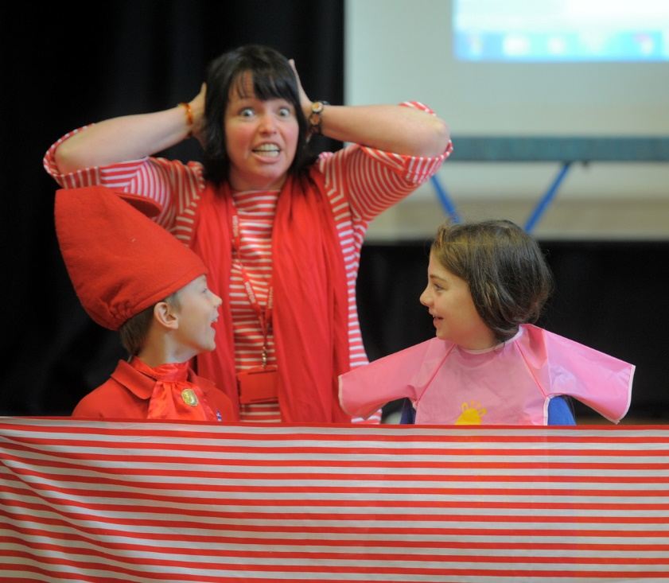
Baby! BE QUIET!!!
Waaah waaah!

13. Amazon Book Review (at the end)
Throughout the writing process, I can check that my writing makes sense and meets its purpose. LIT 2-23a Throughout the writing process, I can review and edit my writing to ensure that it meets its purpose and communicates meaning at first reading. LIT 3-23a
Pupils should write a short online book review to post up on Amazon, Waterstones and/or Goodreads. They should check their work throughout the process, making sure that it makes sense at first reading.

14. Top Trumps Cards (at the end)
I enjoy creating texts of my choice and I regularly select subject, purpose, format and resources to suit the needs of my audience. LIT 1-20a / LIT 2-20a I enjoy creating texts of my choice and I am developing my own style. I can regularly select subject, purpose, format and resources to suit the needs of my audience. LIT 3-20a / LIT 4-20a
Pupils should list as many characters as they can for Punch. Using their own judgment about format, allow each group to create a Top Trumps card game. Each character should get a score for four categories. Possible categories include:

Courage
Strength,
Wisdom
Kindness
Wealth
Likeability

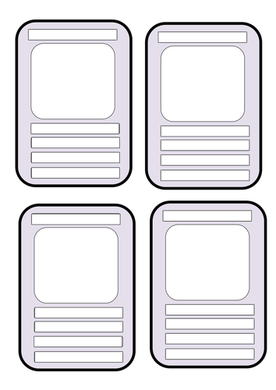Source TES. Image can be enlarged.

